How to Install and Run Apache Kafka on Windows?

Download kafka_2.12-3.9.1.tgz from source

https://kafka.apache.org/downloads

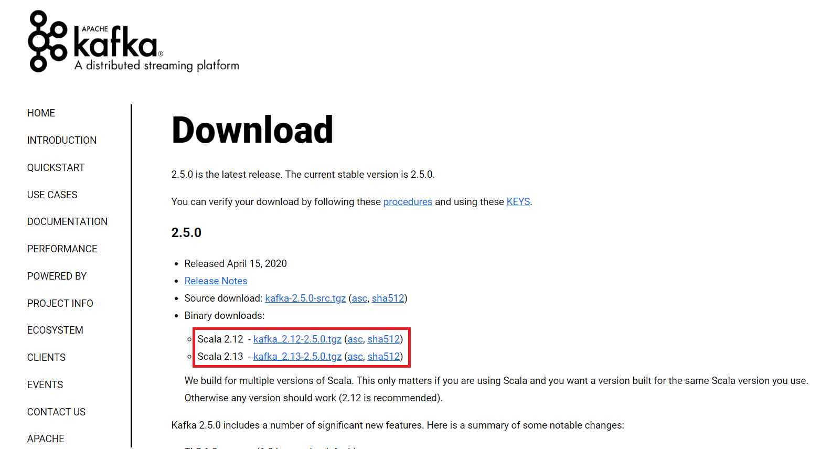

For the installation process, follow the steps given below:

Step 1: Go to the Downloads folder and select the downloaded Binary file.

Step 2: Extract the file and move the extracted folder to the directory where you wish to keep the files.

Step 3: Copy the path of the Kafka folder. Now go to config inside kafka folder and open **zookeeper.properties** file. Copy the path against the field dataDir and add /zookeeper-data to the path.For example if the path is c:/kafka

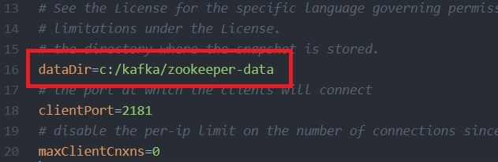

Step 4: Now in the same folder config open server.properties and scroll down to log.dirs and paste the path. To the path add /kafka-logs

Step 5: This completes the configuration of zookeeper and kafka server. Now open command prompt and change the directory to the kafka folder.

First **start zookeeper** using the command given below:

.\bin\windows\zookeeper-server-start.bat .\config\zookeeper.properties

**Fix Error**: This error usually happens because Windows has a command-line length limit of **8191 characters**, and Kafka's startup scripts can exceed this limit due to long paths or excessive classpath entries.

Possible Fixes:

1. **Shorten** the Kafka folder name  
   Rename kafka_2.12-3.9.1 to something shorter, like kafka, and try running the command again.
2. **Move** Kafka to a simpler path  
   Instead of D:\Backup\Softwares\kafka_2.12-3.9.1, move it to D:\Kafka or C:\Kafka to reduce the path length.
3. **Modify** kafka-run-class.bat  
   Open bin/windows/kafka-run-class.bat and replace:

for %%i in ("%BASE_DIR%\libs\*") do ( **call :concat "%%i"** )

**with**:

**call :concat "%BASE_DIR%\libs\*;"**

**Reference:**

rem Classpath addition for release

for %%i in ("%BASE_DIR%\libs\*") do (

rem call :concat "%%i"

call :concat "%BASE_DIR%\libs\*;"

)

1. This prevents excessive classpath concatenation.

**Reference**: D:\AppData\kafka_2.12-3.9.1>**D:\AppData\kafka_2.12-3.9.1\bin\windows\zookeeper-server-start.bat D:\AppData\kafka_2.12-3.9.1\config\zookeeper.properties**

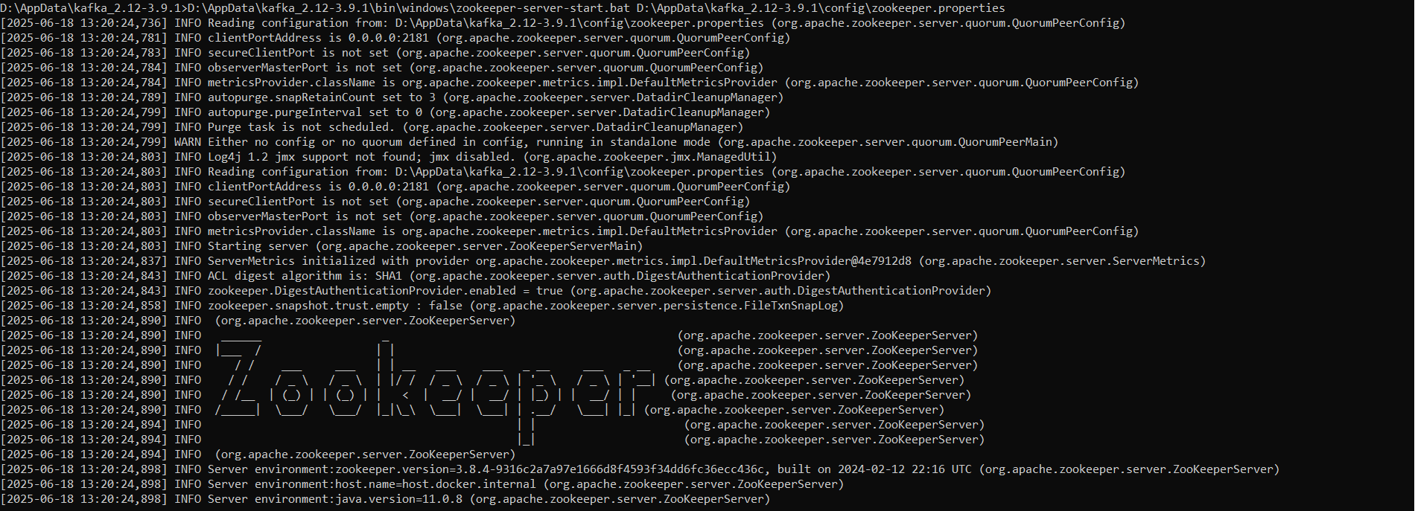

Step 6: Now open another command prompt and change the directory to the kafka folder. **Run kafka server** using the command:

.\bin\windows\kafka-server-start.bat .\config\server.properties

**Reference**: D:\AppData\kafka_2.12-3.9.1>**.\bin\windows\kafka-server-start.bat .\config\server.properties**

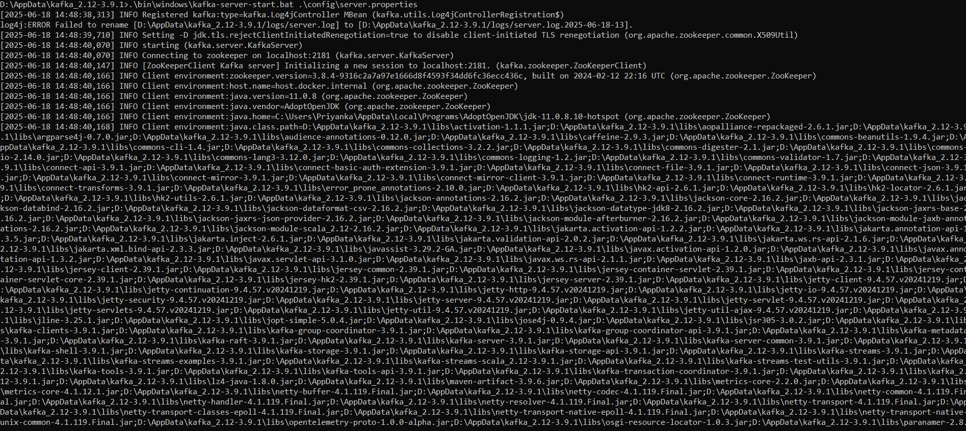

Now kafka is running and ready to stream data.